http://www.guru99.com/creating-keyword-hybrid-frameworks-with-selenium.html
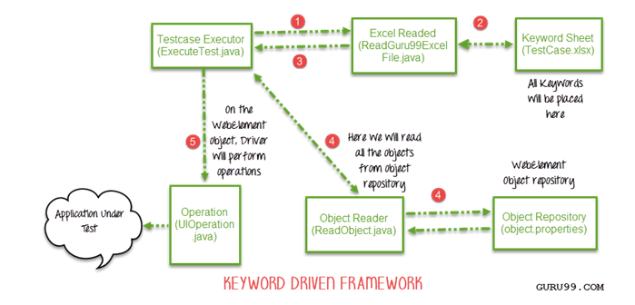
File excel chứa keyword sheet
File properties chứa object repo

